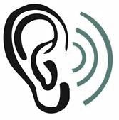
Pasadena
Hearing
Care

Anne S. Carter, Ph.D.
Licensed Audiologist

Amy E. Kelbley
Audiology Assistant

Meg MacAlester
Office Manager

1609 Pasadena Ave. S, Suite 2J
St. Petersburg, Florida 33707
Phone: (727) 329-8852

Documents for VA Evaluation

- Service Treatment Records
  - Enlistment exam
  - Separation exam
  - DD-214
- VA Records from all treatment facilities regarding hearing loss/tinnitus
- All rating decisions/denial letters
  - Please email before evaluation for review by Dr. Carter
- Any hearing tests performed at non-VA facilities
- Username and password for myhealth.va.gov (if applicable)
** Fee for evaluation and report is $500**

